4b) Implement navigation with named routes.
import 'package:flutter/material.dart';
void main() => runApp(const MyApp());
class MyApp extends StatelessWidget {
const MyApp({super.key});
@override
Widget build(BuildContext ctx) {
return MaterialApp(
title: 'Named Routes Demo',
initialRoute: '/',
// Step 1: Define named routes
routes: {
'/': (ctx) => const HomeScreen(),
'/second': (ctx) => const SecondScreen(),
},
// Step 2: Optional — use onGenerateRoute for passing arguments
onGenerateRoute: (settings) {
if (settings.name == DetailsScreen.routeName) {
final args = settings.arguments as DetailsArgs;
return MaterialPageRoute(
builder: (ctx) => DetailsScreen(data: args.data),
);
}
return null; // Default handles routes defined above
},
);
}
}

class HomeScreen extends StatelessWidget {
const HomeScreen({super.key});
@override
Widget build(BuildContext ctx) {
return Scaffold(
appBar: AppBar(title: const Text('Home')),
body: Center(
child: Column(mainAxisSize: MainAxisSize.min, children: [
ElevatedButton(
onPressed: () => Navigator.pushNamed(ctx, '/second'),
child: const Text('Go to Second'),
),
const SizedBox(height: 16),
ElevatedButton(
onPressed: () => Navigator.pushNamed(
ctx,
DetailsScreen.routeName,
arguments: DetailsArgs(data: 'Hello from Home!'),
),
child: const Text('Go to Details with Data'),
),
]),
),
);
}
}

class SecondScreen extends StatelessWidget {
const SecondScreen({super.key});
@override
Widget build(BuildContext ctx) {
return Scaffold(
appBar: AppBar(title: const Text('Second')),
body: Center(
child: ElevatedButton(
onPressed: () => Navigator.pop(ctx),
child: const Text('Go Back'),
),
),
);
}
}

class DetailsScreen extends StatelessWidget {
static const routeName = '/details';
final String data;

const DetailsScreen({required this.data, super.key});
@override
Widget build(BuildContext ctx) {
return Scaffold(
appBar: AppBar(title: const Text('Details')),
body: Center(child: Text(data)),
);
}
}

class DetailsArgs {
final String data;
DetailsArgs({required this.data});
}
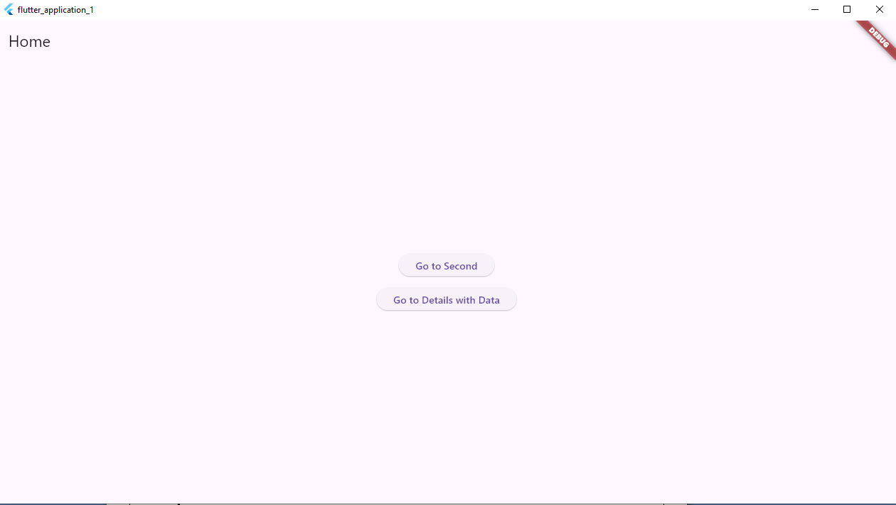
By clicking on go to second the below window will be opened and if you click go back the above window will be displayed
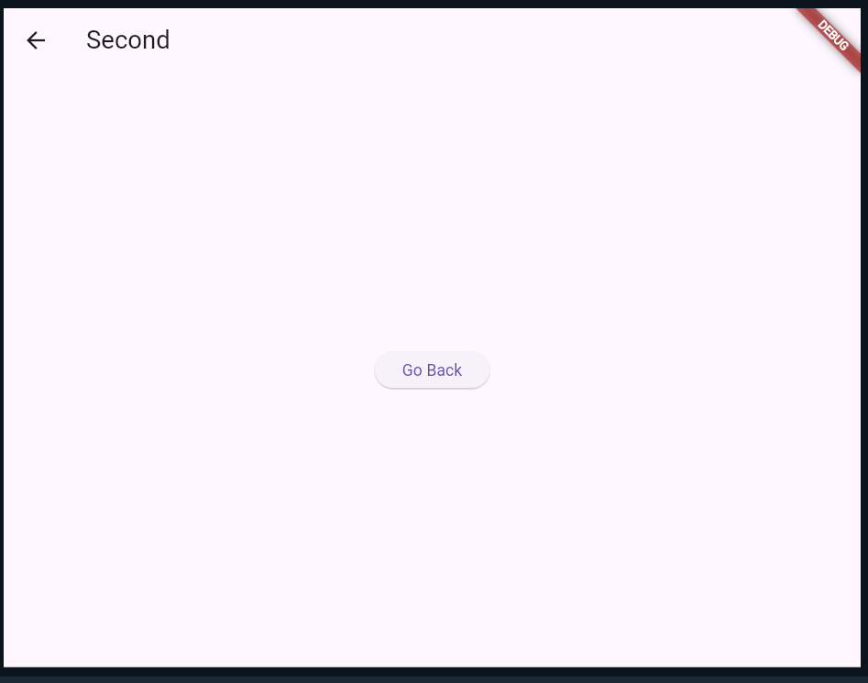
By clicking on go details with data the below window will be displayed
